Compulsory Items for Camp:
PILLOW, FITTED SHEET, SLEEPING BAG
Winter- A Waterproof Coat and Gumboots
Summer- A Sun Hat, drink bottle and Sunscreen

Additional information for Parents:
- Please label your child’s belongings.
- Luggage and sleeping bags are NOT to be tied together. (Bus driver’s request as packing the coach is difficult with these items tied together)

Note: Due to COVID-19 our beds are covered with a plastic mattress protector that is disinfected and sanitized after every camp, therefore the single bed fitted sheet to go over the top is a must, our beds no longer have pillows as previously.

Our Top 20 Essentials to Pack for Camp
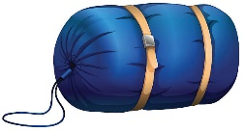  Sleeping bag | Pillow and Fitted Sheet
Shorts for the warmer months | 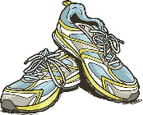  Shoes  Runners or boots for activities
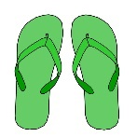  More Shoes!  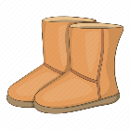  This time river shoes for river activity and slippers/thongs/ or UGG boots for inside. | 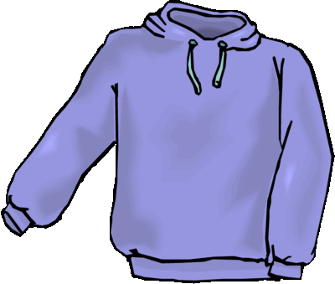  Jumper or Sweatshirt as it gets cold at nighttime
Toiletries | Bathers for water activities
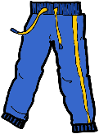  Long Pants/ Leggings for activities | Bath Towel and Towel for water activities
T-shirts or long-sleeved tops | 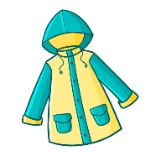  Raincoat and Gumboots  These are a Must in the wet wintery months!
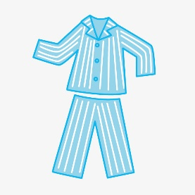  Nightwear and Pajamas | 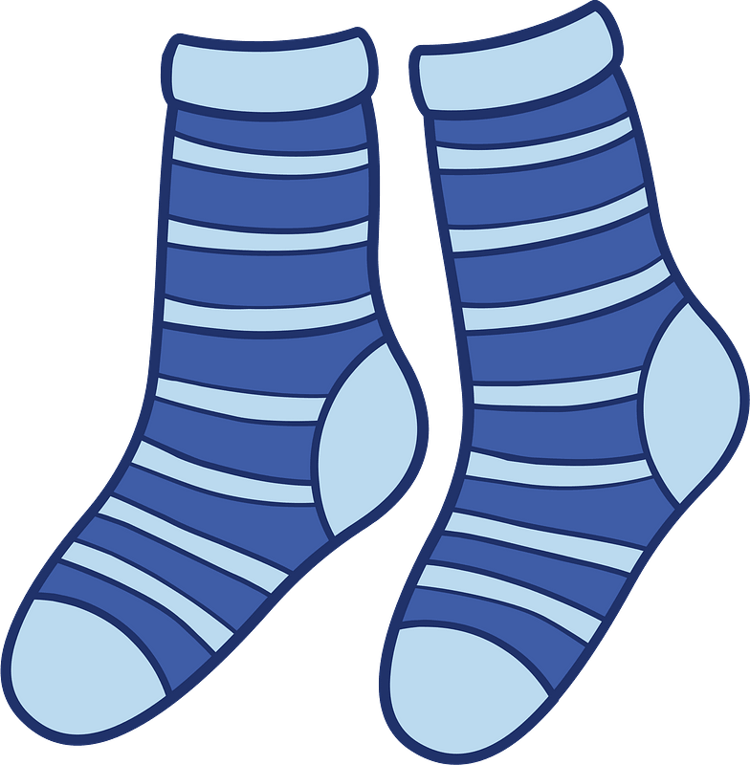  Undies and Socks  Remember to pack extra, just in case!
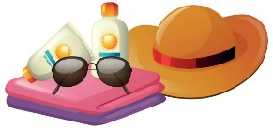  Sun hat | Sunscreen/ Insect Repellant
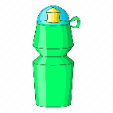  Drink Bottle | Torch for the night walk
Camera | Garbage bag for dirty or soiled clothes

